Shabbos Stories for
Parshas mattos-masei 5779
Volume 10, Issue 50 2 Menachem Av/ August 3, 2019
Printed L’illuy nishmas Nechama bas R’ Noach, a”h

For a free subscription, please forward your request to keren18@juno.com

The Rav’s Response to
The Shabbos Bell Ringer

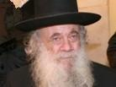

On Friday nights after the meal, Rav Avraham Genechovsky, O”BM, had a chavrusa (learning partner) who would come to his home to learn. One Shabbos evening, the chavrusa - lost deep in thought - accidentally rang the doorbell, violating Shabbos.
The man quickly realized what he had done and become mortified beyond recognition. Luckily for him, no one came to the door. He knocked a couple of times and the Rav finally opened the door - wearing his pajamas!
He apologized profusely, saying that he had forgotten about their study session and had gone to sleep. Only much later did the Chavrusah learn that Rav Avraham had not wanted to embarrass his friend, so he quickly went to bed and only answered the door few minutes later, so that he could pretend that he didn’t hear the doorbell.

Reprinted from the Parshas Balak 5779 email of Torah Sweets Weekly as edited by Mendel Berlin.
How Reb Elimelech Quelled The Rebellion in Nikolsburg
By Asharon Baltazar

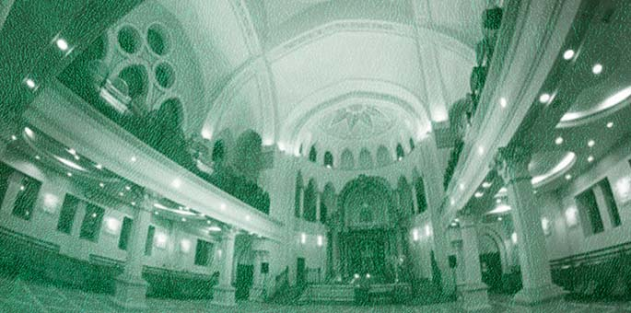

Stepping inside the Jewish quarter of Nikolsburg (today Mikulov, Czech Republic), Rabbi Shmelke Horowitz caught sight of the young men loitering near the entrance. Their faces were clean-shaven, adorned by stylish spectacles, and they held thin canes. A style, he thought despondently, inspired by gentile fashion. Trying to counter the waves of modernity sweeping in from the West seemed futile. Had his rabbi, the Maggid of Mezeritch, not insisted he accept the Nikolsburg rabbinical position, he would’ve turned on his heel and returned home immediately.
Instead, he approached the young men, extended his hand greeting, and chided them for abandoning Jewish tradition.
“Usually,” he began, “when a person ages—developing white hair, failing eyesight, and difficulty walking unassisted—he realizes his end in this world is near and is inspired to repent. Seeing this, the Yetzer Hara, the evil inclination, introduced a new idea. ‘Already in their youth, I’ll have them shave, walk around with a cane, and wear glasses. This way, as they near death, they’ll remain impassive, never feeling compelled to repent, allowing me to effortlessly guide them to their miserable end.’”
Rabbi Shmelke’s rebuke was seen as an invitation to war.
Life for the rabbi became unbearable. The “enlightened” Jews employed every strain of power they had. To oust the rabbi, some of the town’s most distinguished community members hinted that perhaps he was wrongly suited for a city as “modern and developed” as Nikolsburg. Their words cut Rabbi Shmelke deeper than any of the attempts to ruin his life.
Hundreds of miles to the west, deep in the Polish heartland, Rabbi Elimelech of Lizhensk was hurrying to the mikvah when a voice stopped him mid-step.
“The man who endeavors to save Rabbi Shmelke from his tormentors in Nikolsburg will merit the World to Come!”
Rabbi Elimelech turned to the man escorting him. “Did you hear that?”
The man answered with a shake of his head.
Rabbi Elimelech repeated his question to a passerby, who only looked at him blankly. After asking multiple people about the voice and receiving the same negative answer, Rabbi Elimelech became convinced the voice was directed at him. Not hesitating for a moment, he flagged over the first wagon he saw and ordered a ride to Nikolsburg, a distance of several hundred miles.
Upon arrival, Rabbi Elimelech approached Rabbi Shmelke and requested his permission to assemble the townspeople for a sermon in the synagogue. “This disrespect has to cease immediately.”
“Perhaps take it slowly?” suggested Rabbi Shmelke warily. “This here isn’t Lizhensk. The people in Nikolsburg aren’t receptive to some things, and those things are better left unsaid. I say this only for your own good.”
But Rabbi Elimelech insisted. Word of the famous visitor spread throughout town, and at the appointed hour, a crowd—including many of Rabbi Shmelke’s opponents—poured into the synagogue, filling the chamber from wall to wall. Surprisingly, Rabbi Shmelke’s seat was empty.
To everyone’s bewilderment, Rabbi Elimelech spoke as though he sympathized with the opponents of the rabbis. He spun arguments for more leniency and less rabbinic involvement, mesmerizing all those present. Not one objected, even after he finally fell silent.
“Due to time constraints,” Rabbi Elimelech announced, “I’m unable to complete what I originally planned to say. And so, I would like to invite everyone back tomorrow.”
Nikolsburg was still aflame the next day from Rabbi Elimelech’s speech. The crowd in the synagogue swelled beyond capacity, forcing many to crowd outside the doorway. From the podium, Rabbi Elimelech looked around and noticed with satisfaction that all the men, women, and children of the town were waiting eagerly in their seats. He had achieved the first stage of his plan.
He picked up where he had left off, only this time he refuted yesterday’s words. Gracefully paired with persuasive proof, Rabbi Elimelech explained that all institutions of our Sages are infallible and mustn’t be altered in the slightest; those who defy their words are wicked and their end will be bitter. Rabbi Elimelech continued to rebut everything he had said previously.
Sighs from the crowd, sporadic at first and becoming more frequent with the passing minutes, began to accompany his words. As Rabbi persisted in his gentle rebuke, those sighs transitioned into sniffling whimpers and eventually sobs. Not a dry eye remained. The Jewish community of Nikolsburg was churning in the turmoil of repentance.
When he felt confident the crowd in the synagogue realized the enormity of their errors, Rabbi Elimelech described the gift from Heaven that was Rabbi Shmelke Horowitz. They had merited such a righteous man, and all they did was try to chase him away.
Rabbi Elimelech finished speaking, and a solemn silence followed his words. Without a word, the entire crowd rose, lined up, and began shuffling toward Rabbi Shmelke’s home to apologize—some for the way they treated him, others for failing to defend his honor.
Rabbi Shmelke was in his room when he noticed the large crowd heading his way, and he feared the worst. “What has Rabbi Elimelech done to provoke the ire of the entire community?” he wondered in fright. “Now they will be out for blood! What have I done?!”
The door opened, and the heads of Nikolsburg’s Jewish community walked in, their heads bowed in shame.
“We have come to ask for forgiveness,” said one of them in an undertone, too ashamed to look Rabbi Shmelke in the eye. “Our treatment has been inexcusable. We promise that we will change our ways for good, and this will not happen ever again.”
After an emotional farewell from a most grateful Rabbi Shmelke, Rabbi Elimelech departed back to Lizhensk.

Reprinted from the Parshat Pinchas 5779 email of Chabad.Org Magazine. Adapted from Sichat Hashavua, # 1060.

The Cause of the Brit Milah

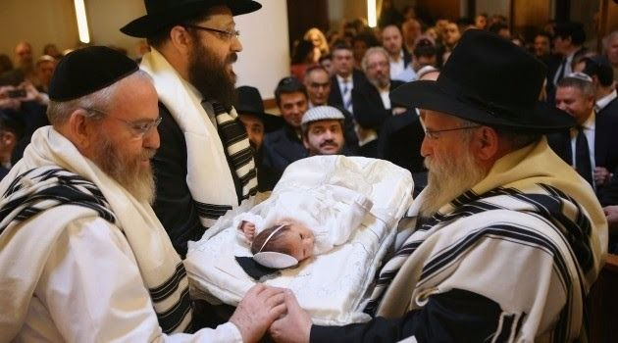

Rabbi Zev Smith recounted that he once attended the brit milah of a boy who was the first child of a couple who had been married for 20 years. The father stood up to speak, and emotionally described the trials and tribulations that he and his wife had gone through.
“I’m sure you can imagine,” he told his guests, “all the blessings we received from rabbis, and all the heartfelt prayers we recited.” He then proceeded to tell how he heard about a great tzaddik who was visiting the United States. He made it a point to go see him to ask for a berachah.
When he asked the rabbi for his blessing, the rabbi asked if he had been praying. The man was insulted by the question. “What does The Rabbi think I'm doing for the last 20 years?” he wondered.
However, he swallowed his feelings and respectfully told the rabbi, “Yes, of course I have been praying.”
“You don’t understand,” the rabbi replied. “Did you ever pray with the firm belief that Hashem is the only One Who can help you? Did you ever put out of your mind everything the doctors have been saying, to focus on the fact that this is all the Will of Hashem? Or was Hashem just a side point along with the doctors the whole time?”
The man immediately acknowledged that the rabbi was right. He never really prayed with that kind of emunah. “This child,” the man said at his son’s milah, “is testimony to the fact that when you truly believe that Hashem is the source of your salvation, He comes through for you.”

Reprinted from the Parashat Balak 5779 email of Rabbi Amram Sananes as written by Jack Rahmey

The Rosh Yeshiva’s
Subway Fare

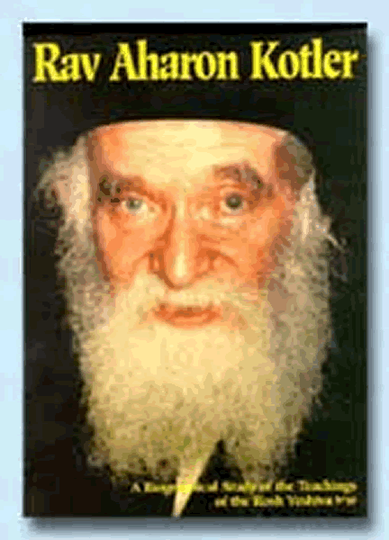

Rav Aharon Kotler, zt”l, was the driving force behind many worthy Tzedakah organizations. One evening, after a meeting with the board members of a certain Tzedakah, almost everyone had left to go home, and one Rabbi noticed that Rav Aharon was staying behind.
He asked him why the Rav wasn’t leaving, and Rav Aharon explained to him that he didn’t have ten cents for the subway ride to get home. Hearing this, the Rabbi reflected to himself how Rav Aharon was in charge of various organizations which dealt with millions of dollars. It also occurred to him that it was undoubtedly in the best interest of the organization for Rav Aharon Kotler to come to meetings, and even for him to return home when they were over.
Anyone could have easily made a good case to grant permission for Rav Aharon to take the ten cents he needed from the funds of the Tzedakah, but a good case for Rav Aharon Kotler was not good enough. He wouldn’t take a penny from what was raised for Tzedakah.
This Rabbi reached into his pocket and took out some change. He knew Rav Aharon wouldn’t take a gift, so he said, “I’m lending the Rosh Yeshivah twenty cents. Ten cents will be for the subway, and the other ten cents will be there just in case the Rosh Yeshivah takes the wrong train and has to switch to the right one!”

Reprinted from the Parshas Balak 5779 email of Torah U’Tefilah as compiled by Rabbi Yehuda Winzelberg.

One Can Always
Do Teshuvah

There is a powerful story in the Gemara (Avodah Zarah 17a), about Elazer ben Durdaya, who strayed from the path of Jewish life and became addicted to certain Aveiros. One day he was told that he would not be accepted in repentance, even if he were to try to do Teshuvah.
He became overwhelmed and shocked by his low level, and he felt a deep desire to return to Hashem. He went to seek external help. He sat between two mountains and hills and said, “Mountains and hills, pray for mercy on my behalf, so that my Teshuvah will be accepted!” They said to him, “Before we pray for mercy on your behalf, we must pray for mercy on our own behalf.”
He said, “Heaven and earth, pray for mercy on my behalf!” They said to him, “Before we pray for mercy on your behalf, we must pray for mercy on our own behalf.”
He said, “Sun and moon, pray for mercy on my behalf!” They said to him, “Before we pray for mercy on your behalf, we must pray for mercy on our own behalf.”
He said, “Stars and constellations, pray for mercy on my behalf!” They said to him, “Before we pray for mercy on your behalf, we must pray for mercy on our own behalf.”
Elazar ben Durdaya said, “Clearly, the matter depends on nothing other than myself. He placed his head between his knees and cried loudly until his soul left his body.
A Divine Voice emerged and said, “Rebbi Elazar ben Durdaya has earned his life in Olam Haba! When Rebbi Yehuda HaNasi heard this story, he cried and said, “There are those who acquire their share in Olam Haba only after many years of hard work and toil, and there are those who acquire their share in Olam Haba in just one moment!”
Rebbi Yehuda HaNasi further commented, “Not only are Baalei Teshuvah accepted, but they are even called ‘Rebbi’, as the Divine Voice referred to Elazar ben Durdaya as ‘Rebbi Elazar ben Durdaya!’”
In one brief moment of serious realization, Teshuvah, and change, Elazar ben Durdaya made a complete turnaround in his life and earned S’char in Olam Haba!

Reprinted from the Parshas Balak 5779 email of Torah U’Tefilah as compiled by Rabbi Yehuda Winzelberg.

A Surprising Way to Sanctify His Late Mother

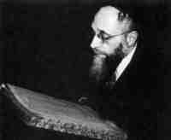

Following the Arab riots in Eretz Yisroel in 1929, the Agudas Yisroel announced a special campaign to raise funds for the victims. Rav Elya Meir Bloch, zt”l, was asked to make an appeal in the town of Ponevezh, an undertaking which at that time involved a train journey of twelve hours from Telz.
Arriving at Ponevezh when it was time for Minchah, Rav Elya Meir asked if he could be the Chazan, since he was observing his mother’s Yartzeit that day. They asked him in surprise, “If the Rosh Yeshivah has Yartzeit for his mother today, how could he travel all day on a train, without any opportunity to say Kaddish?” The train had left before the time for Shacharis.
Rav Elya Meir replied, “What do you think my mother would prefer, that I say ‘Yisgadal V’Yiskadash Sh’mei Rabbah’, or that I act in a way that actually causes Hashem’s great Name to become great and sanctified? I am sure that my mother has much greater satisfaction from me trying to collect money for the victims of the Pogrom, for this is more important to her than saying Kaddish.”
His students later related that when Rav Elya Meir returned to Telz, he repeated this sentiment to them, because he wanted them to absorb a correct scale of values!

Reprinted from the Parshas Balak 5779 email of Torah U’Tefilah as compiled by Rabbi Yehuda Winzelberg.

Story #1126
The Shwarma Rebbe
From the desk of Yerachmiel Tilles
editor@ascentofsafed.com



David Deri used to own a kosher meat restaurant in Manhattan's. One day, he noticed a man enter tentatively and begin to look over the menu that was laying on the table nearest the entrance. He was wearing jeans with a few holes and patches, and a shirt that had clearly seen better days - a not so unusual look on the streets of New York in those years. He approached this unpromising looking customer.
"Hello, sir. My name is David. How may I help you?"
"Hi. I'm James. I'd like shwarma."
David looked at him curiously. He had included shwarma on the menu only because there were Israelis that liked to drop in from time to time. But Israelis, he knew, were not likely to respond to being called 'James.'
He couldn't hold himself back from asking. "How do you know what is shwarma?"
"Whaddya talking about?" responded James like a true Jew. "All my life I've eaten shwarma." Then he added emphatically, "I'm an Israeli."
"And your name is 'James?' David wondered if perhaps he had heard incorrectly.
James laughed. "My real name is Chayim, However, here in America I decided to adopt a more popular name."
David decided to utilize the opportunity; he was, after all, a Chabadnik, a follower of the Lubavitcher Rebbe. He began to pepper their exchange with words of Torah. James' facial expressions indicated that he quickly grasped the theme and that he enjoyed hearing ideas that were new to him.
After a series of visits to the restaurant, in which James ordered a large portion of shwarma and received it each time seasoned with Torah thoughts, David suggested to him that he subscribe to a weekly one-on-one Torah class with a Lubavitch Yeshiva student, who would contact him to arrange a mutually convenient hour.
"Why not?" James responded, smiling, handed to David one of his business cards. David had never inquired about what James did for a living, so he was quite surprised to discover that James was the CEO of a large investment firm on Wall Street!
That evening David gave the card to a yeshiva student he was acquainted with, named Shneur. In the next few weeks, David didn't see James at all. Had he switched restaurants? Did he come in the hours when David was not there? He didn't know. In any case, the incident soon passed from his mind and he didn't think about James at all.
But then, after several months, it occurred to David that he hadn't seen James in such a long time, and he wondered what had happened with him. He phoned Shneur, and asked him if he was still in touch with James.
"Am I still in touch with him? I certainly am. And our connection has become much stronger," was the response David heard, to his joy.
And more good news was still to come.
Shneur continued. "Know that James purchased his own pair of tefillin and puts them on faithfully every [week] day. Not only that, he also has taken on to observe Shabbat! - at least partially, at any rate."
* * *
Years passed. David was standing behind the cash register when a religious-looking Jewish man entered the restaurant. The man looked around and, upon noticing David, rushed over to him, grabbed his hand, and began shaking it enthusiastically.
"Do you remember me?" he asked, still grasping David's hand.
David didn't.
The man smiled triumphantly. "I'm James!"
David gulped. "Of course I remember you. But you certainly look different," he added, staring at the kippah adorning James' head and his overall well-groomed appearance.
"That's right. I wear a kippah all the time now. And it is all because of you!" he snapped with mock indignation.
"Here's what happened," James continued. "I began to study with Shnuer, the yeshiva boy you told to call me, by telephone once a week. In one of those sessions, we encountered the Rebbe's idea that those who have very little Torah knowledge should take it upon themselves to teach the little they know to another Jew who unfortunately doesn't even know that much.
"This idea was difficult for me to digest. I asked Shneur, how could it possibly be that someone like me, who not only knows very little, but also is not mitzvah observant, is qualified to teach the holy Torah?
"Shneur easily deflected my concerns, and went on to convince me that I could do it, that me too the Rebbe had in mind.
"Right then on the telephone, I decided I would arrange a Shabbat party every week for the Jews among my employees and customers, and that in addition to the food I would have catered, I would share with them the teachings that I was learning with Shneur.
"To host the Shabbat parties, I rented a large gallery space in an upscale building in Manhattan. The parties became an instant hit. No doubt the long tables aligned along one wall laden with a wide variety of food from the best kosher catering available was a major element. Still, the highlight each week was my presentation of the Torah teachings of the Lubavitcher Rebbe.
"From week to week the number of people requesting to be invited grew, until after a few months I had no alternative but to assign the regular participants into shifts that would attend on alternate weeks.
"The moment finally came when I could no longer push aside the realization how inappropriate it was to be having Shabbat parties in which the Shabbat laws were not being adhered to. Even more, that I, the organizer, host and teacher, was only partially Shabbat observant. After a brief inner struggle, I had to accept that the time had come: I would be fully Shabbat observant!
"Once I actualized my Shabbat commitment, other mitzvahs came smoothly in its wake. Eventually, I decided to take the plunge and change my life to be a full-fledged religious Jew in all its implications.
"More time went by and then I met a wonderful religious Jewish woman. We got married, thank G-d, and we moved to Canada."
"See the power of shwarma!" David commented wryly. Then he winked and patted James on the shoulder.
"Hold on," protested James. "The story I came to tell you is not yet finished.
"A few weeks ago - like now - I flew into New York on a business trip. I was walking on a street in Manhattan when suddenly a kippah-wearing Jew approached me and greeted me excitedly. 'Rabbi James, hi!' he exclaimed emotionally.
"'Rabbi' he called me, no less! Meanwhile, I had no idea who he was.
"Then he began pumping my hand and wouldn't let go. 'You should know that you changed my life!' he said, to my open-mouthed amazement.
"It turned out that he was one of the regulars at those Shabbat parties I used to organize while I still lived in New York. The words of Torah he heard each week seeped into his heart and, like with me, percolated there until he realized that he had to change his lifestyle, and accept upon himself to live according to Torah andmitzvot.
"Do you get it, David? Without me even realizing it, the Lubavitcher Rebbe turned me of all people into a shliach -- one of his emissaries to inspire other Jews to return to their roots, thus bringing closer the final redemption."
James laughed. "Yes, that was genuinely powerful shwarma that you served me."
Source: Translated and adapted by Yerachmiel Tilles from the weekly, HaGeula, #990.
Connection: Seasonal -- Shabbat, Tammuz 3, is the 25th yahrzeit of the Lubavitcher Rebbe.
Biographical note: Rabbi Menachem Mendel Schneerson, the Lubavitcher Rebbe [11 Nissan 5662 - 3 Tammuz 5754 (April 1902 - June 1994 C.E.)], became the seventh Rebbe of the Chabad dynasty after his father-in-law's passing on 10 Shvat 5710 (1950 C.E.). He is widely acknowledged as one of the greatest Jewish leaders of the second half of the 20th century.
Although a dominant scholar in both the revealed and hidden aspects of Torah and fluent in many languages and scientific subjects, the Rebbe is best known for his extraordinary love and concern for every Jew on the planet. His emissaries around the globe dedicated to strengthening Judaism number in the thousands. Hundreds of volumes of his teachings have been printed, as well as dozens of English renditions.

Reprinted from the Parashat Chukat 5779 email of KabbalaOnline.org, a project of Ascent of Safed.
Rebbe Zusha and the Rav

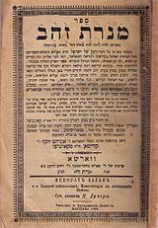
Book by Rabbi Zusha of Anapoli, "Menorat
Zahav" (Candelabra of Gold). Edition from 1902

In the town of Anipoli there were two Rabbis, Rebbe Zusha the Chassid, and the town Rav, a Misnagged. R’ Zusha was always happy despite the fact that he had nothing but troubles, poverty, and ill health.
The Rav on the other hand, despite his honorable position in the community, was always unhappy, depressed, bitter and angry. He could not bear others, or even himself.
One night, bitter and frustrated he went to ask R’ Zusha for help. He sneaked out of his house at an hour when he would not be seen and secretly made his way to the hovel which R’ Zusha called home.
When he arrived, the lamps were still burning, so he knocked hesitantly. Almost immediately R’ Zusha appeared at the door with a smile and an invitation to enter.
“How is it that you are so happy and content and I am always angry and cursing everybody?” asked the bewildered Rav.
“Let me give you an example,” offered R’ Zusha. “Take the wedding of R’ Moshe’s daughter. When Reb Moshe, the local oshir (wealthy man), made a wedding for his daughter recently, he dispatched a messenger to personally invite the special citizens of Anipoli.
“When the messenger came to your house, you demanded to see the guest list. You saw that you were 14th on the list.”
‘“Chutzpah!’ you shrieked, and decided that you would attend, but come late. When you arrived, all the guests were already sitting at the tables and eating the festive meal. When you arrived, there were no empty places to be found.
“Soon, Reb Moshe the philanthropist saw you looking for a place to sit. ‘Rabbi,’ he called out, ‘where have you been?’ He brought you to the head table, but there were no more empty places. They brought you a chair, but you sat behind somebody else.
“You were furious, looking for somebody to lash out at, but nobody was really paying any attention to you. The waiter did not even see you. By the time the host noticed that you were not eating, all the food was gone.
“R’ Moshe went into the kitchen to find something, but there was nothing befitting the Rav of Anipoli. Everything had already been picked through. By this time you were cursing the host, the waiters, the guests, and even the bride and groom themselves.
When it came time for the bentching and the Sheva Brachos, you had been all but forgotten. You went home broken, angry, and bitter, even cursing the Master of the World Himself.
“When the messenger came to the house of R’ Zusha (he always referred to himself in the third person), Zusha was taken aback. What a kind gesture! Reb Moshe is inviting Zusha to the wedding of his daughter?! What has Zusha ever done to deserve an invitation to their wedding?!
“So Zusha went two hours early to the wedding. Zusha asked what he could do to help set up. Zusha officiated at the ceremony. Zusha ate a full meal. Zusha was honored with bentching and Zusha recited the Sheva Brachos.”
“You see”, Rebbe Zusha continued his explanation to the Rav of Anipoli, “you wanted everything, but you ended up with nothing. Zusha didn’t ask for anything, but he got it all!”

Reprinted from an email sent by Jonas Knopf.

